Lab Report of Python Programming

Lab 2: List, Tuples, Sets and Dictionaries Credit hour: 2

Student Name: Student ID:

## ￣￣￣￣￣￣￣￣￣￣￣￣￣￣￣￣￣￣￣￣￣￣￣￣￣￣￣￣￣￣￣￣￣￣

1. Objective
   1. Know how to define a list and access the elements in a lists; practice to create some program using lists and multidimensional lists;
   2. Know how to create tuples and use tuples as immutable lists;
   3. Know how to use sets for storing and fast accessing non-duplicate elements and understand the performance differences between sets and lists;
   4. Know how to store key/value pairs in a dictionary and access value using the key and how to use dictionaries to develop applications.
2. Lab content
   1. Write a program to get input from the keyboard, calculate the Mean, Standard Deviation and Median by using **list** to save the data.
   2. Count the word frequency (top 10) by using **set**:   
      Read from the file **hamlet.txt** and count the word frequency.
   3. Random password generation by using **list**:   
      Generate ten passwords randomly illustrated as follows that comprised of eight characters, which can only be 26 letters in lower case or 9 digits from 0 to 9.

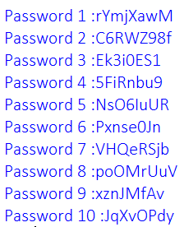

* 1. To determine the duplicate element by using **list** and **set** separately and analyze which one is better.
  2. By importing **jieba** library to realize the Chinese word frequency counting which read from the **三国演义.txt**.
  3. Textbook P497 14.10

1. Code list
2. Output
3. Analysis and conclusions